About this document.

Content blocks are arranged as a one-page datasheet document to be used in a PDF, or even printed.
A datasheet is commonly used later in the sales process to address technical questions for buyers.
Please do not edit the factual information, but feel free to add anything further to personalise this for your business and conform with your brand guidelines, so please use the blocks as a starting point to get started.

Please do not use this material without first updating, personalising the content and adding your brand guidelines to the layout.

Remote Tech Ltd

Module  DATASHEET | LOGO

Size and weight options  W65 x H28 x L101mm | W2.55 x H1.10 x L3.97 inches  135 grams | 0.29 pounds (with 2 batteries) | 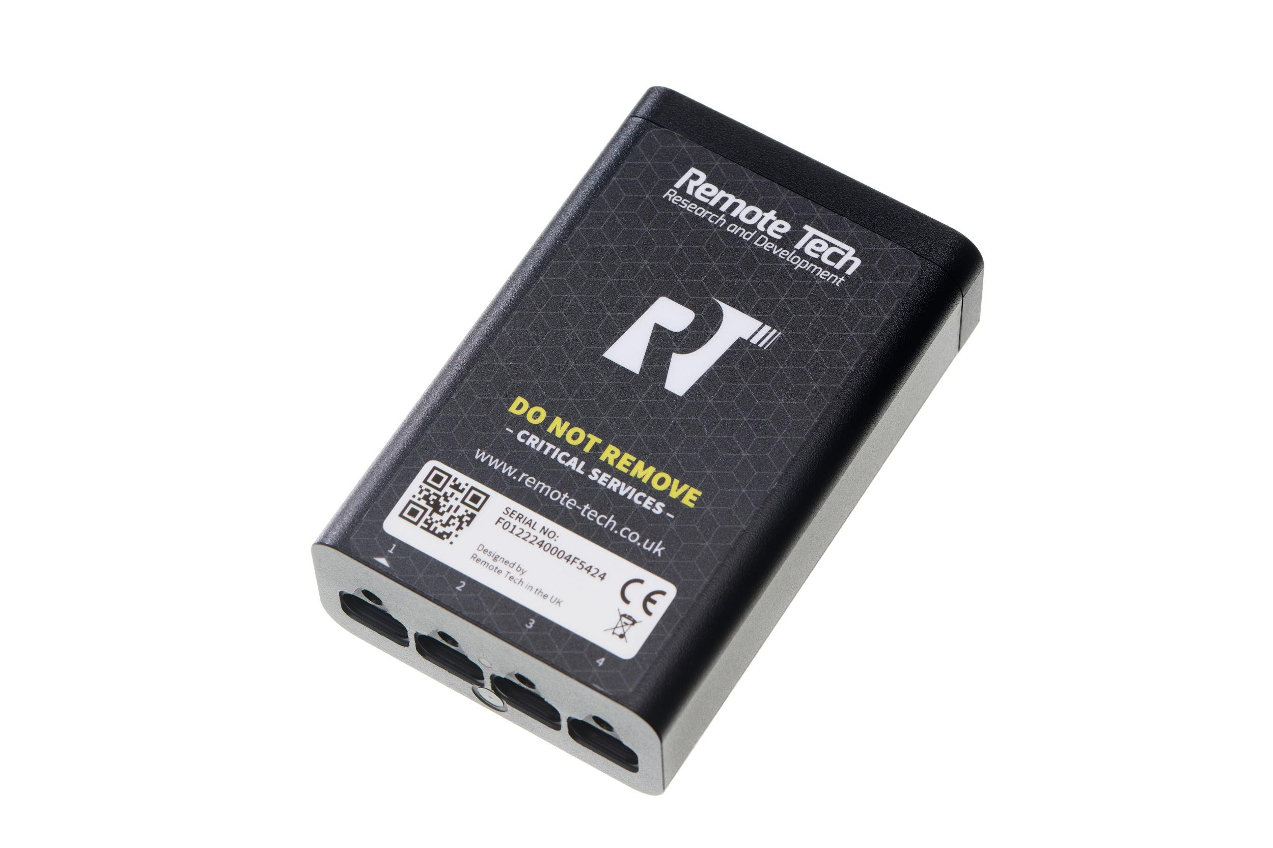  IMAGES from Image Library
Key Features  Arm Cortex-M33 processor  10-year battery life or power via USB-C port  1 x USB-C with I2C and 3 x USB-C - I2C only  Status LED Indicator  Plug and Play to add 4 sensors.  2-way encrypted communication and (OTA) Over the Air Updates  Lifetime Warranty | Operating Considerations  UV-stabilized polycarbonate body  IP67 rating - Weatherproof and Water resistant up to 1m.  Operating temperatures: -40° to 85°C  LoRa radio communications with Gateway  NFC Antenna (used for commissioning)


Contact us today and discuss how remote temperature monitoring can help you.
- Contact Details/ logo etc (Partner badge from marketing resources)

