About this document.

Content blocks are arranged as a one-page datasheet document to be used in a PDF, or even printed.
A datasheet is commonly used later in the sales process to address technical questions for buyers.
Please do not edit the factual information, but feel free to add anything further to personalise this for your business and conform with your brand guidelines, so please use the blocks as a starting point to get started.

Please do not use this material without first updating, personalising the content and adding your brand guidelines to the layout.

Remote Tech Ltd

Temperature Sensor  DATASHEET | LOGO

Size and weight options  0.5 m - 15 grams - 0.03 pounds  1.0 m - 25 grams - 0.05 pounds  1.5 m - 35 grams - 0.08 pounds  2.0 m - 45 grams - 0.10 pounds  5.0 m - 125 grams - 0.25 pounds  10.0 m - 225 grams - 0.50 pounds | 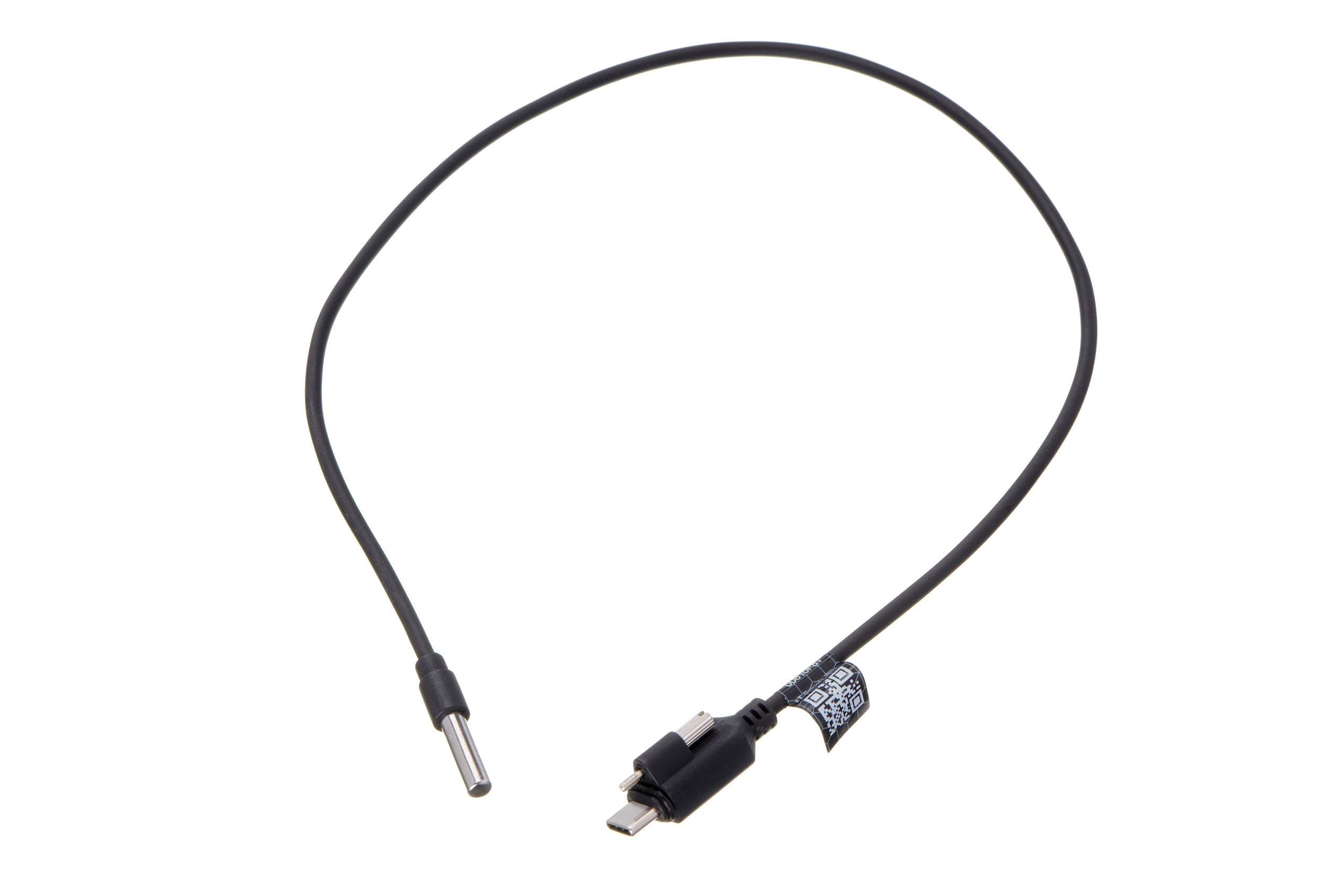  IMAGES from Image Library
Key Features  Plug and Play  2-way encrypted communication and (OTA) Over the Air Updates  Lifetime Warranty | Operating Considerations  IP68 rated - Fully dust tight  Submersible underwater for extended periods without issue.  Operating temperatures: -40° to 85°C


Contact us today and discuss how remote temperature monitoring can help you.
- Contact Details/ logo etc (Partner badge from marketing resources)

