About this document.

This document provides some ideas for content blocks that you might use to develop product brochure/collateral for your company, more quickly.
Used with the product images, technical datasheets, partner badge and other marketing materials you have what you need to get started.
A product brochure/collateral is commonly used throughout the sales process to reinforce your key messages to buyers.
We have laid the content blocks out as a two-page document to be used in a PDF or print.
This of course depends on your brand guidelines, so please use the blocks as a starting point to get started.

Please do not use this material without first updating, personalising the content and adding your brand guidelines to the layout.

Remote Tech Ltd

Take your legionella temperature monitoring to the next level.  Always-on Legionella temperature monitoring to simplify and improve awareness and control. | LOGO

Consistently monitoring water temperatures can be difficult.  Are inconsistent or inaccurate readings affecting your ability to manage risk?  Are you frustrated that your company temperature readings cannot be easily accessed and shared?  Do you lack the staffing, time, or budget to undertake regular measurements?  Are your employees or customers struggling to accommodate monthly engineer visits? | An innovative, new approach, can bring many benefits, including:  - Go Green: improved supply chain sustainability supports CSR and net-zero targets.  - Compliance assured: automate regular temperature monitoring tasks and follow LCA/HSE guidelines.  - Less Disruption: reduce engineer visits to your premises by up to 66%  - More accurate logs: with 240 times more readings every month available on your desktop and to share.  - Faster response: complete remedial works to solve identified issues quicker and control your risk.

Would you like to investigate or try this new approach (Your personal CTA)

Get in touch with your account manager today (or other)

Remote temperature monitoring is the perfect complement for our skilled engineers.

A modular solution for reliable and consistent temperature monitoring.  - The L8Log Digital logbook is an online portal to track remote and manual activities.  - Smart Temperature Sensors are IP68 rated, accurate to 1 degree and accurately capture readings from your critical assets.  - Modules with a 10-year battery life can connect up to four sensors; transferring readings via a gateway to your dashboard.  - Gateways connect to the internet using a SIM card and transmit readings securely to L8Log.  The service meets LCA and HSE ACoP L8 ‘Legionnaires’ disease guidelines. | 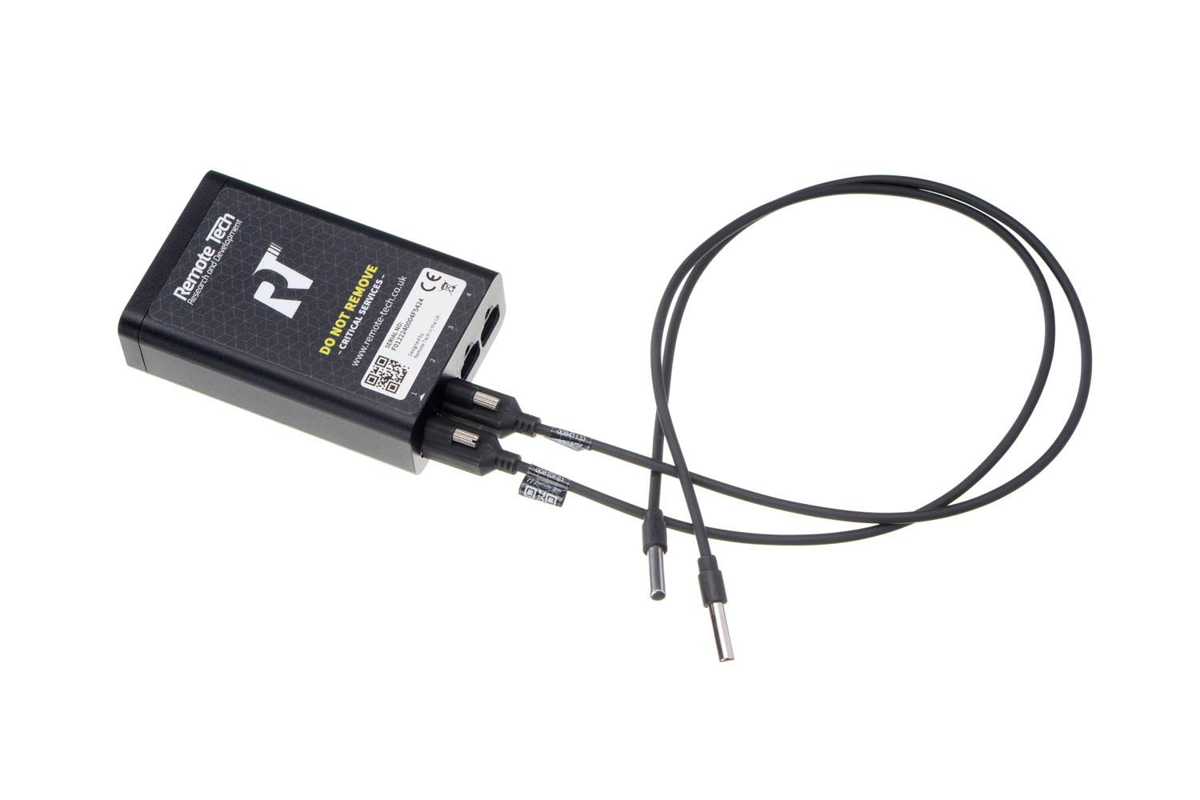  IMAGES from Image Library  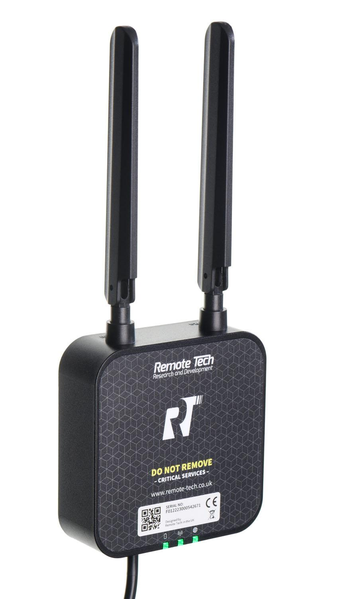

Why [partner name]
Add information on your company and the benefit of working with you specifically.

What others say
Add your company’s testimonials | another


Contact us today and discuss how remote temperature monitoring can help you.
- Contact Details/ logo etc (Partner badge from marketing resources)

Some Longer Copy to review and use if desired

What are the benefits of remote temperature monitoring for legionella control
Remote temperature monitoring can provide several benefits for Legionella control, including:
- Early Detection: Remote temperature monitoring can provide early detection of changes in water temperature, which can help to identify potential breeding grounds for Legionella bacteria before they become a problem.
- Rapid Response: By monitoring temperature remotely, it is possible to respond quickly to any temperature fluctuations and take immediate corrective action. This can help to prevent the growth and spread of Legionella bacteria.
- Improved Efficiency: Remote temperature monitoring can reduce the need for manual temperature checks, which can be time-consuming, disruptive to your buildings and labour-intensive. This can save time and resources, allowing for more efficient and effective Legionella control measures.
- Regulatory Compliance: Remote temperature monitoring can help to ensure compliance with LCA and HSE Guidelines for Legionella control. It can provide accurate and reliable data for reporting purposes, helping to demonstrate compliance with regulatory guidelines.
- Increased Safety: By reducing the risk of Legionella contamination, remote temperature monitoring can help to increase the safety of building occupants and reduce the risk of Legionnaires' disease.

What problems are associated with legionella temperature monitoring?
Legionella temperature monitoring is an essential aspect of managing the risk of Legionnaires' disease, a severe form of pneumonia caused by Legionella bacteria.
However, there are several problems associated with Legionella temperature monitoring, which include:
- Inaccurate temperature measurements: The accuracy of temperature measurement devices can be affected by factors such as the placement of the probe, the temperature range, and calibration issues. This can lead to inaccurate temperature readings, which can result in ineffective control measures.
- Inconsistent monitoring: Legionella temperature monitoring needs to be carried out regularly and consistently to identify any potential issues. However, this can be challenging, particularly in larger buildings or systems where monitoring is more complex and time-consuming.
- Human error: Temperature monitoring relies on people to carry out the checks, and mistakes can be made, such as failing to record readings accurately or missing monitoring intervals.
- Lack of data analysis: Monitoring data must be collected, analysed, and used to inform control measures. However, this may not happen in some cases, leading to missed opportunities to identify and address issues.
- Misinterpretation of data: Interpreting monitoring data can be challenging, particularly for those without specialist knowledge, leading to inappropriate or ineffective control measures.
- No remedial action: Effective Legionella control requires a range of measures, not just temperature monitoring. Relying solely on temperature monitoring may lead to a false sense of security and potentially overlook other risk factors. You must act on the risks identified.

Overall, Legionella temperature monitoring is an essential aspect of Legionella control, but it must be carried out consistently, accurately, and analysed appropriately to be effective.

